N. Durga Sravani Profile
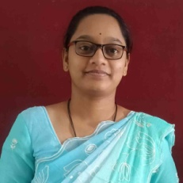
- Name : N. Durga Sravani
- Designation : Lecturer in Chemistry
- Date of Birth : 25 – 11 - 1998
- Educational Qualifications : M. Sc. APSET.
- Teaching experience : 3 Months
- Research Experience : NIL
- Dissertation/Thesis Title : NIL
- No. of Research publications : NIL
- No. of Books Published : NIL
- No. of Major/Minor Research Projects: NIL
- Title of Minor Research Project : NIL
- No .of International Conferences Attended : NIL
- No. of National Conferences Attended : NIL
- No. of Papers Presented at the Seminars/Conferences: NIL
- Refresher Courses/Orientation Programs/Training Programs Attended: NIL
- Vidwaan Score : NIL
- Address : D/O N N S Murali Krishna,
Siddantham, Penugonda,
West Godavari - 534326
- E-mail Id : nadelladurgasravani@gmail.com
- Contact No : 8639465418

